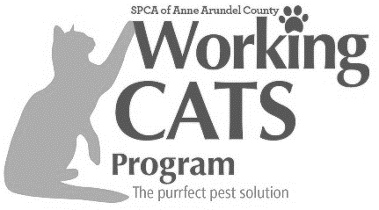
SPCA of
Anne Arundel County
SPCA Contact Information
Email: adoption@aacspca.org
FAX: (410)268-8027
1815 Bay Ridge Ave
Annapolis, MD 21403

Date: _________

Working Cat Application

Applicant Information

Full Name: Driver’s License #:
Last First M.I.

Address:
Street Name Apartment/Unit #

City State Zip Code

Phone: Email:

Will your cat reside at your residence or business? ☐ Home/Residence ☐ Business ☐ Barn/Stable

If the cat will reside at your place of business, please provide business name and complete address:

Business Name:

Business Street Address:
City: State: Zip Code: County:

Do you own or rent the residence/business? ☐ I rent ☐ I own

If renting, list owner’s name: Phone number:

Who will be responsible for the care of the cat once the lease has completed?

Please describe the property/building where the cat(s) will live, including the structure where they will be acclimated/permanently housed (If the structure is not secure and escape-proof enough for the
REQUIRED 3-4 week acclimation period, a large dog crate or similar cage may be used):

How far is the property located from the main road?

What other types of animals reside on the property?

Is there a protected/warm area for outdoor animals during winter? ☐Yes ☐No ☐Partially

Please tell us why you are looking to give a home to a working cat:

How many cats are you able to accommodate? ☐ 1 Cat ☐ 2 Cats ☐3 Cats ☐4+ Cats

What types of cat(s) are you looking for your barn/place of business? (We will do our best to find the best match.)

☐Feral ☐Semi-Feral ☐Friendly (may still have some behavioral issues)

Are you willing to provide outdoor cats with fresh food/ water daily? ☐Yes ☐No

Do you agree to trap and provide medical care should the cat become ill/injured? ☐Yes ☐No

Are you willing to let a member of AACSPCA visit your home by appointment? ☐Yes ☐No

Have you ever had a working cat before? If yes how many, how long did you have them, and what happened to them?

Disclaimer and Signature
I certify that my answers are true and complete to the best of my knowledge. I understand that providing false information can and will void my application. I authorize AACSPCA to verify the provided information. I also understand that the AACSPCA reserves the right to deny my application.

Print Name: Date:

Signature: Date:

